Bionic Ankle
申报上海青少年科学社 2025级高级会员
项目名称及目的

一．查新项目概况
- A bionic ankle that can help disabled people to walk
- Consists of two motors in the upper part of the leg to drive the bionic ankle, a universal joint to act as the human joint, and a movable foot.
- Used a better spring system to mimic human’s ankle function
- Uses 2 motors to allow a 2-dimensional movement for better adaption
- Added inversion and eversion movements
- Used ADAMS to model the kinematics for optimized lengths
- Uses PID controller to move the leg

二．查新点

- Inversion and Eversion movements
- Spring system
- PID controller
- ADAMS simulation

三．文献检索范围及检索策略
文献检索范围：
□中国知网
□维普期刊网
□万方数据知识服务平台
□中国学术期刊网络出版总库
□国家知识产权局网
□中国国家数字图书馆
□中国重要报纸全文数据库
□百度学术
√Google 学术
□搜索引擎（如百度、谷歌）
□其他： 检索词：
Inversion Eversion bionic ankle
PID bionic ankle

四．检索结果

[1] Title: A Multiaxial Bionic Ankle Based on Series Elastic Actuation With a Parallel Spring

Authors: Shun Zhao, Wei Liang, Kunyang Wang, Lei Ren, Zhihui Qian, Guangrong Chen, Xuewei Lu, Di Zhao, Xu Wang, Luquan Ren

Publisher: IEEE

The paper describes the developing of a 2 degree-of-freedom bionic ankle using springs and a four-SEAPS-based spring mechanism. The bionic ankle exhibits a high land-buffering performance.

This paper is similar to my bionic ankle in terms of having a 2 degree-of-freedom, and also a strong parallel spring mechanism.

This paper is different from my bionic ankle in the method to optimize the numbers of the ankle. I used ADAMS to get a virtual environment, which eventually reaches to completely different statistics in the maximum degree to move the ankle, the height of the ankle.

[2] Title: Control of Bionic Robot Leg Performance with Proportional Integral and Derivative Controller

Authors: W. Widhiada, T. G. T. Nindhia, I. M. Widiyarta, and I. N. Budiarsa

Publisher: International Journal of Mechanical Engineering and Robotics Research

The paper introduces the concept of PID controlling to bionic ankles and knees which proves to quickly achieve a stable response.

This paper is similar to my bionic ankle in terms of using a PID controller to quickly, and accurately control the bionic ankle.

My bionic ankle adds a second degree-of-freedom to the human ankle, mimicking the human ankle better.

五．查新结论
After searching on Google Scholar, and comparing the articles, the conclusions are as following:

- There is an article with a similar mechanical structure, but have different statistics, ways of improvement and approaching the bionic ankle.
- There is an article with a similar controlling method, but a more limited mobility of the ankle.

There are many similar researches on bionic ankle, the characteristic of my bionic leg are as following:
- Uses PID controlling mechanism to provide an accurate, quick method to move the ankle to its specific angle.
- Have inversion and eversion to improve the balancing and adaption of the bionic ankle
- Using ADAMS to simulate the movement of the bionic ankle for improvements

Some bionic ankles that have been published have some of these characteristics, but do not exhibit them all.

According to the above, the bionic ankle shows innovation through using ADAMS to help create a unique PID controlled 2 DoF bionic ankle.

六．附件清单

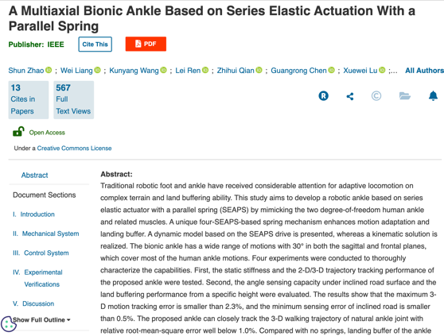

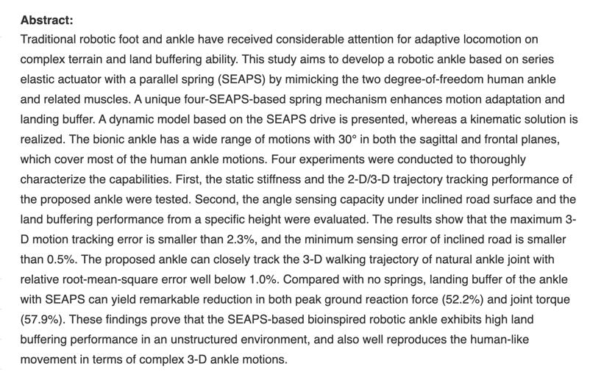

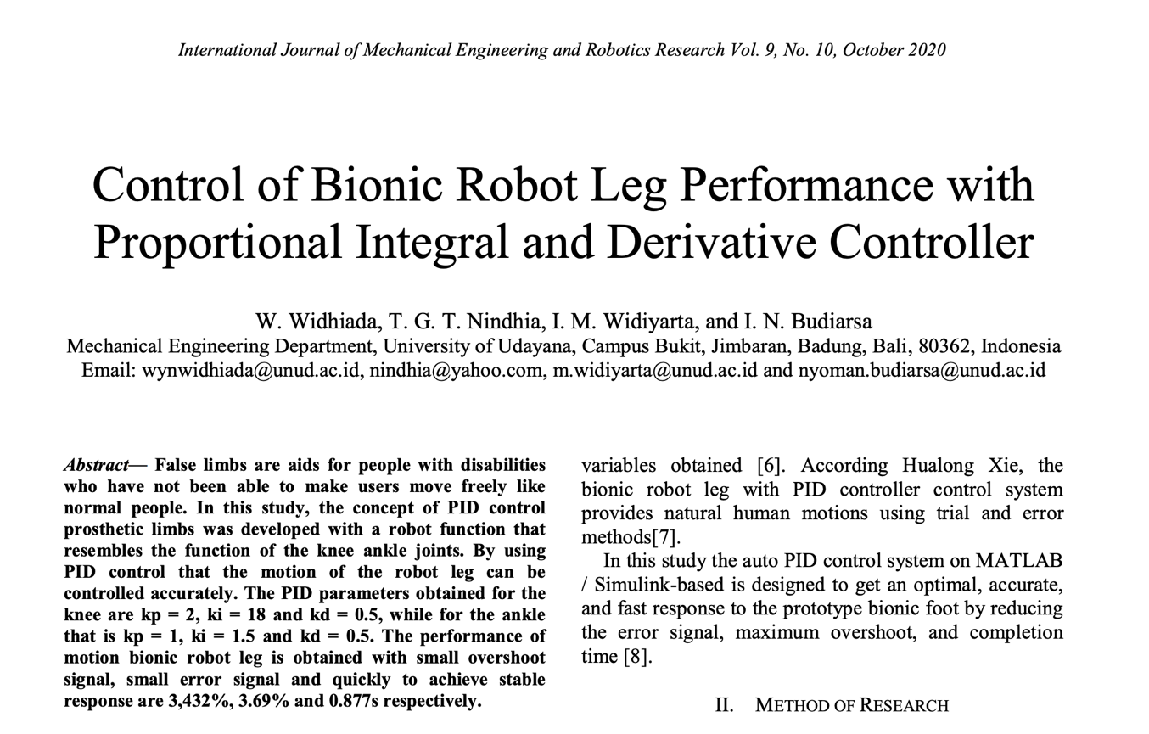

七．备注

八．发明团队成员、指导教师签字的查新声明
（签署此查新声明，即表明所提交的查新报告中的陈述事实真实准确，团队成员 将对报告中的所有内容负责。）
发明团队成员签名（手写） ：

